**TUGAS KELIMA**

**STATISTIKA DESKRIPTIF**



**NAMA : MUKHAMAD IKHSANUDIN**

**NIM : 082011633086**

**S1 SISTEM INFORMASI**

**FAKULTAS SAINS DAN TEKNOLOGI**

**UNIVERSITAS AIRLANGGA**

**2021**

library(readxl)

AllData <- read_excel("JK, TB, Umur, Pend.xlsx")

View(AllData)

1. Pengolahan Data Nominal

# Menggunakan data Jenis kelamin

JK = table(AllData$`Jenis Kelamin`)

1. Barplot

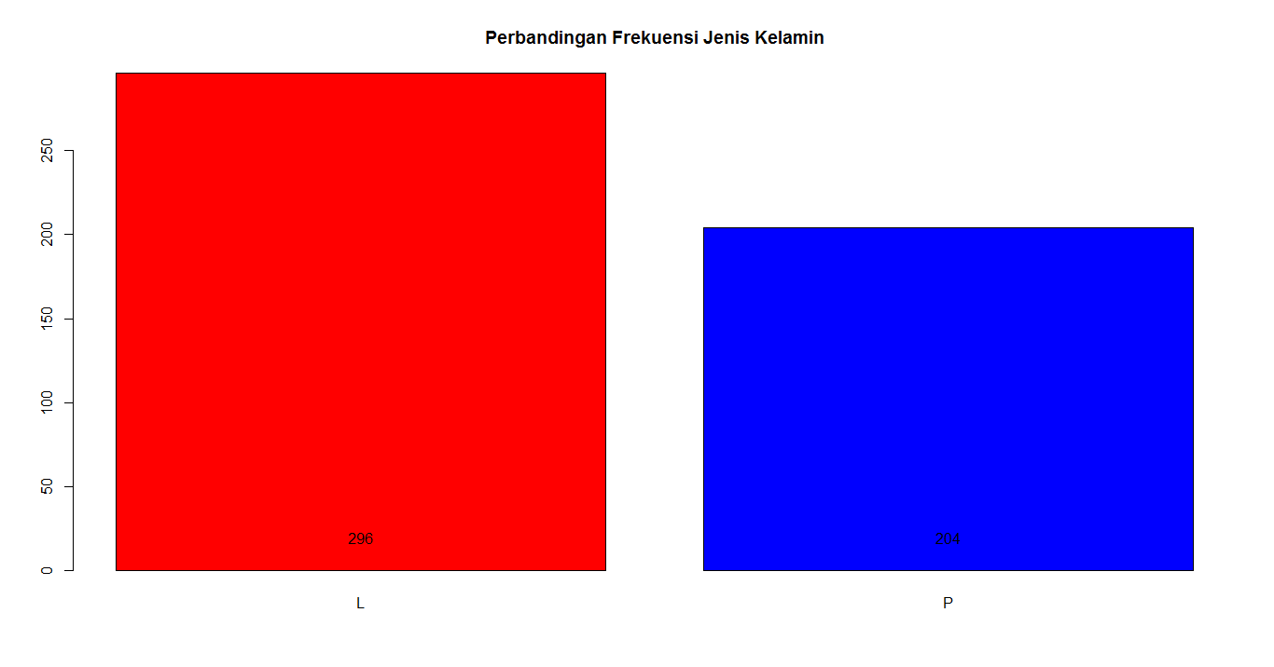text(barplot(JK, main = "Perbandingan Frekuensi Jenis Kelamin", col = c("red", "blue")), 20, JK)

1. Pie Chart

persen <- round(JK/sum(JK)*100)

NewJK <- paste(persen, "%", sep = " ")

pie(JK, radius = 1, labels = NewJK, col = c("red", "blue"), main = "Perbandingan Frekuensi Jenis Kelamin")

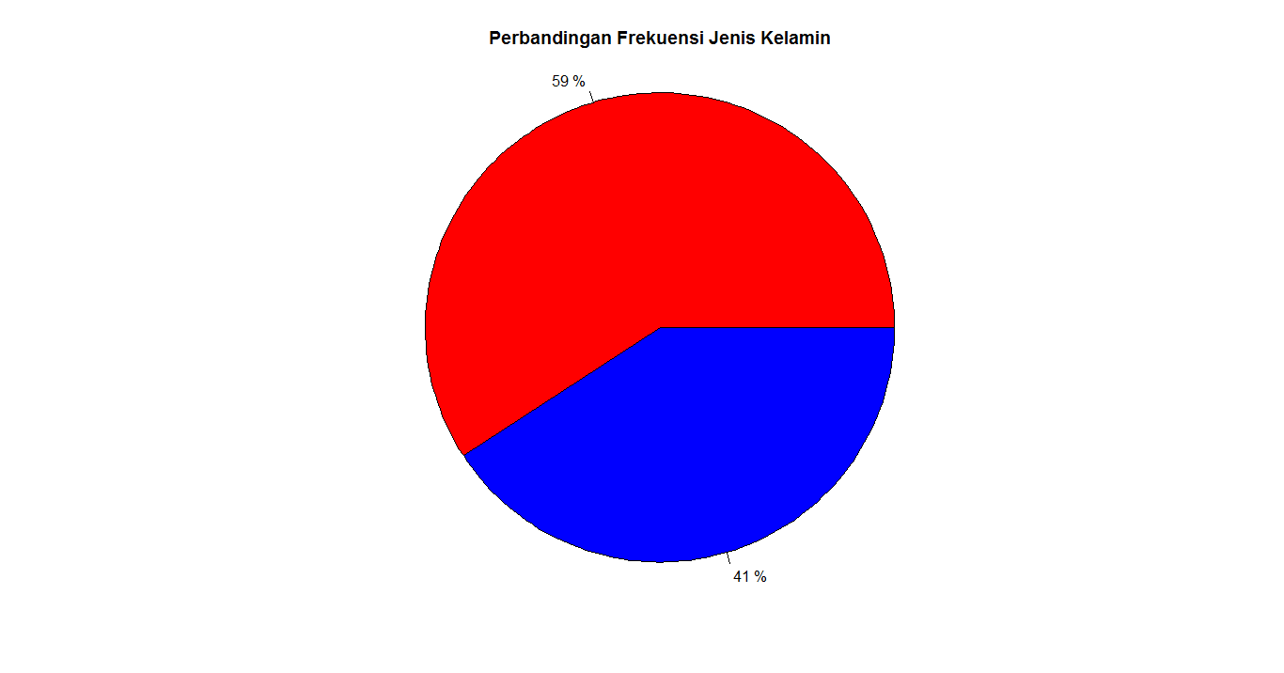

1. Plot

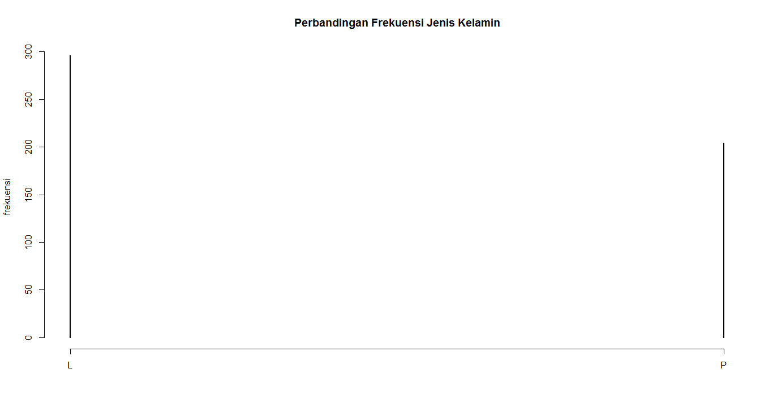plot(JK, ylab = "frekuensi", main = "Perbandingan Frekuensi Jenis Kelamin")

1. Scatter Plot

text(plot(JK, ylab = "frekuensi", main = "Perbandingan Frekuensi Jenis Kelamin", type = "p"), 20, JK)

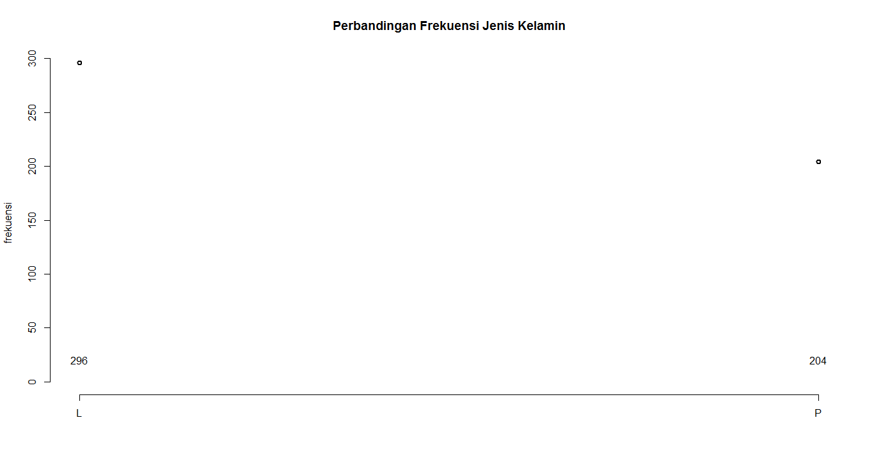

1. Pengolahan Data Ordinal

# Menggunakan data Pendidikan Terakhir

Pend = table(AllData$`Pendidikan Terakhir`)

1. Barplot

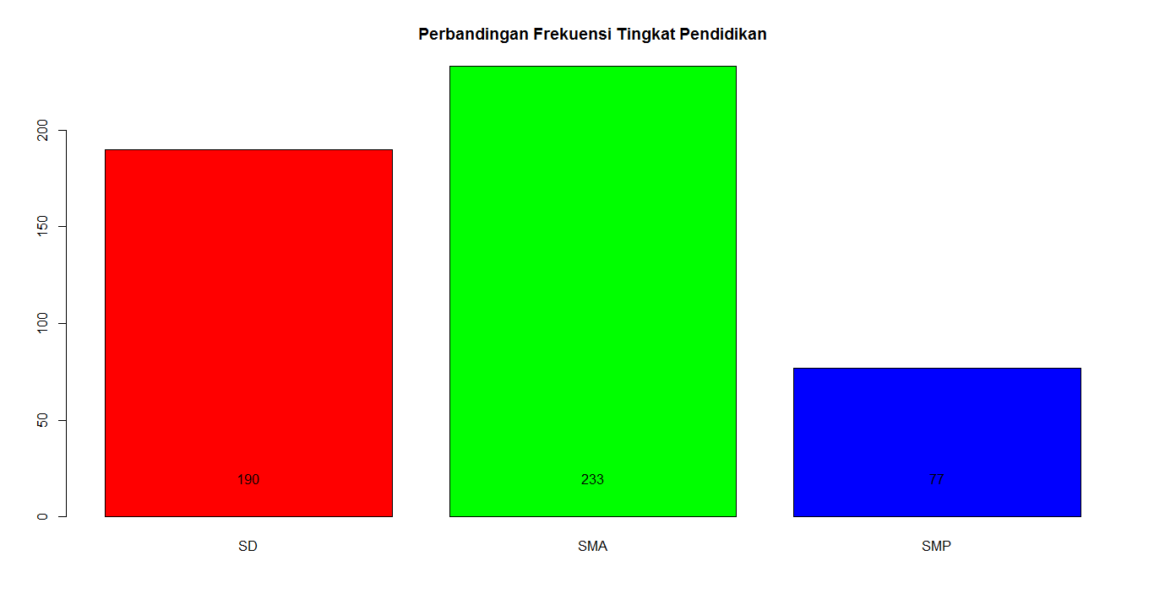text(barplot(Pend, main = "Perbandingan Frekuensi Tingkat Pendidikan", col = rainbow(3)), 20, Pend)

1. Pie Chart

pie(Pend, radius = 1, labels = Pend, col = rainbow(3), main = "Perbandingan Frekuensi Tingkat Pendidikan")

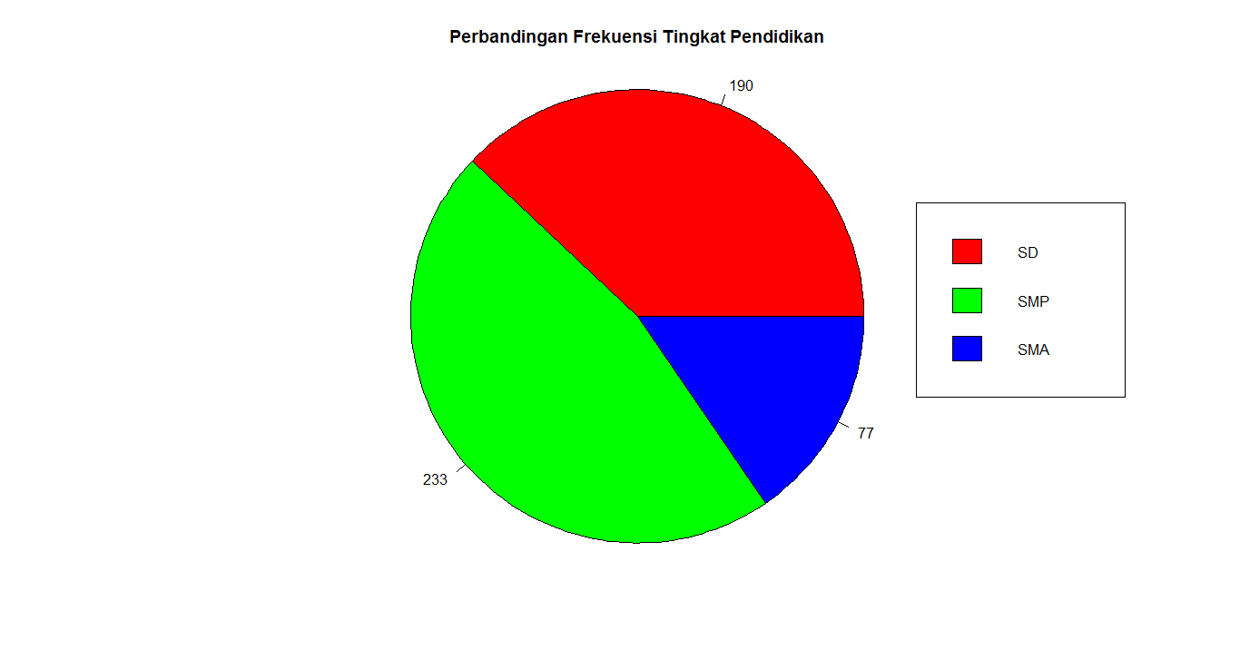legend(1, 0.5, c("SD", "SMP", "SMA"), cex = 1, fill = rainbow(3), xjust = -0.25)

1. Plot

plot(Pend, ylab = "frekuensi", main = "Perbandingan Frekuensi Tingkat Pendidikan")

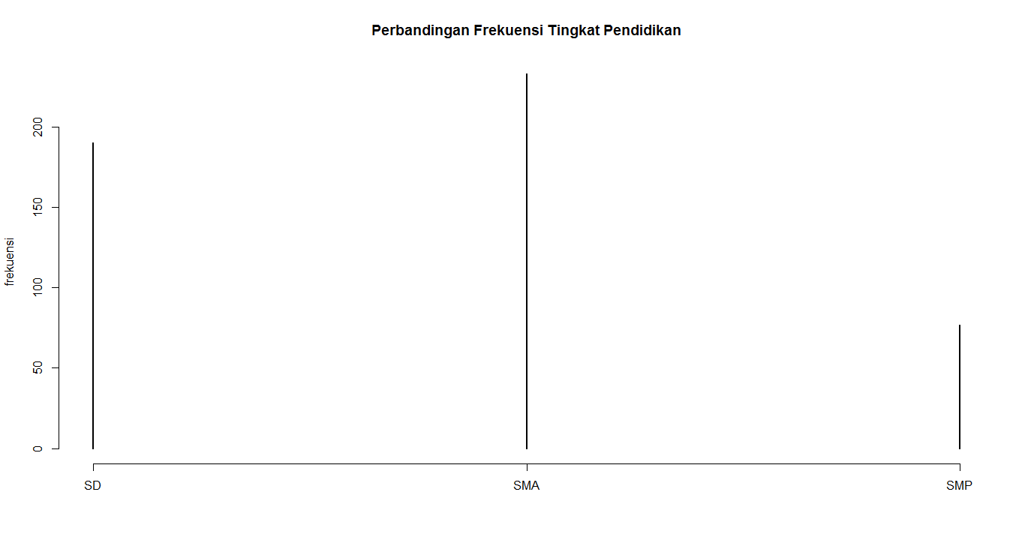

d. Scatter Plot

text(plot(Pend, ylab = "frekuensi", main = "Perbandingan Frekuensi Tingkat Pendidikan", type = "p"), 20, Pend)

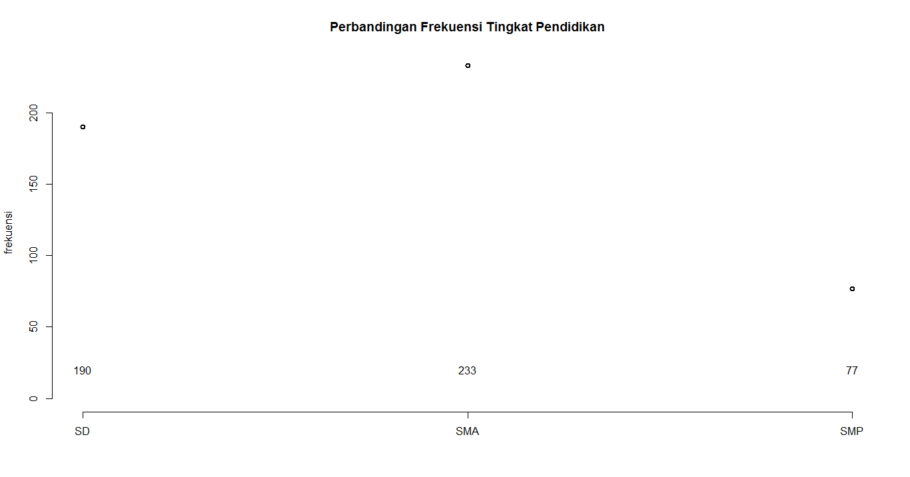

1. Pengolahan Data Rasio

# Menggunakan data Tinggi Badan

TB <- table(AllData$`Tinggi Badan`)

1. Barplot

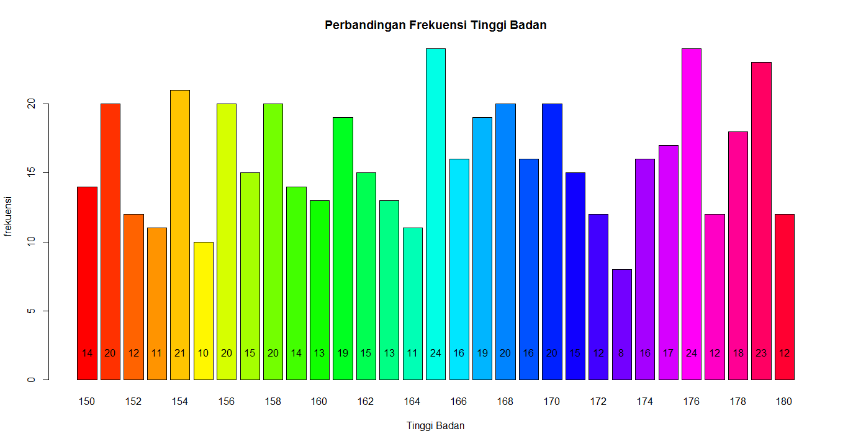text(barplot(TB, main = "Perbandingan Frekuensi Tinggi Badan", col = rainbow(31), xlab = "Tinggi Badan", ylab = "frekuensi"), 2, TB)

1. Pie Chart

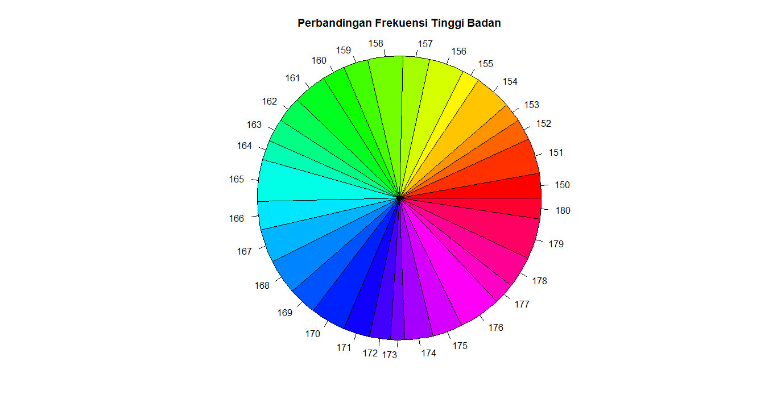pie(TB, radius = 1,clockwise = FALSE, col = rainbow(31), main = "Perbandingan Frekuensi Tinggi Badan")

1. Histogram

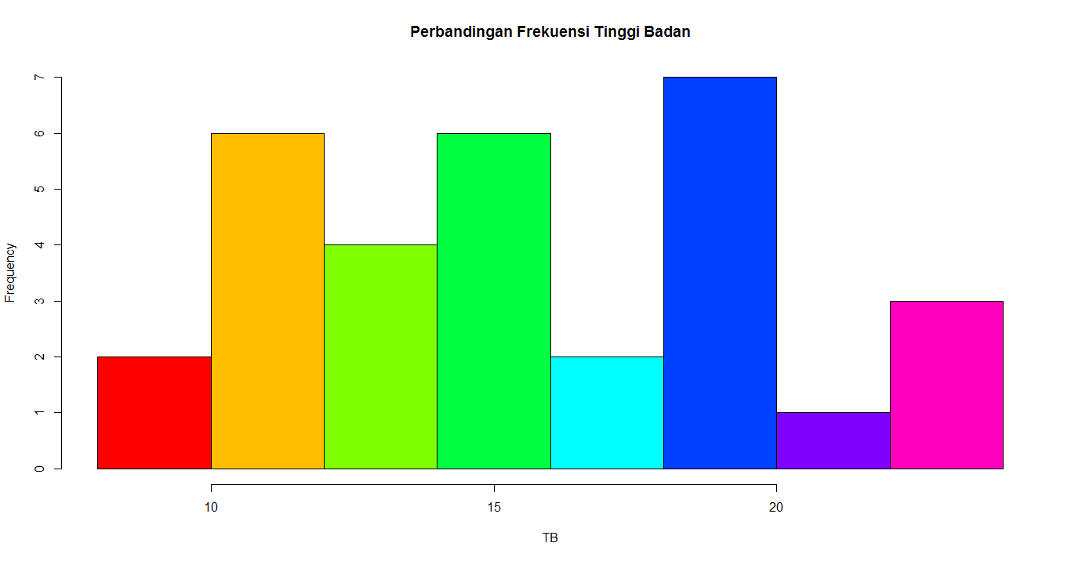hist(TB, col = rainbow(8))

1. Plot

plot(TB)

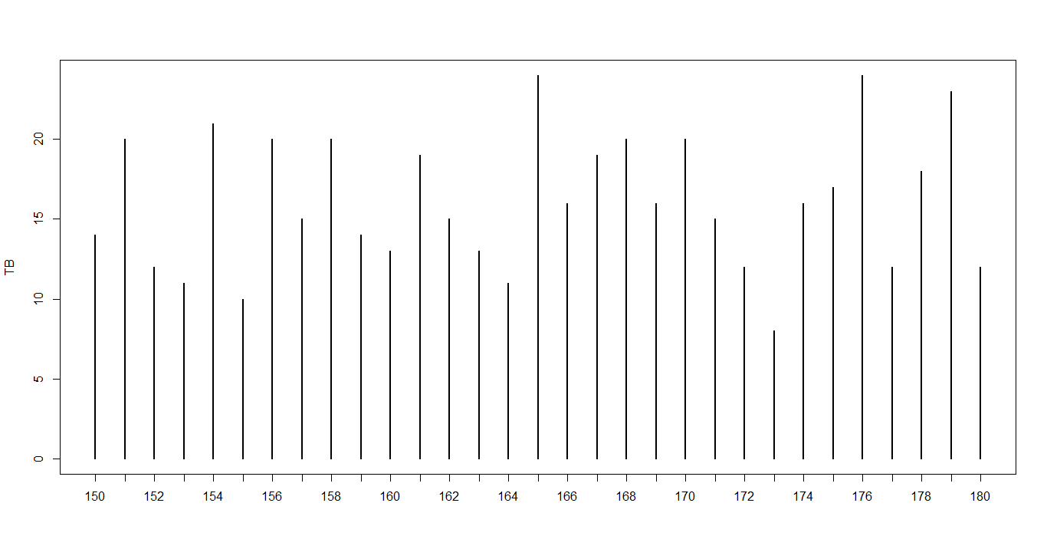

1. Scatter Plot

plot(TB, type = "p")

